Spalding Monkhouse School

01/03/2018 to 31/03/2018

Correction Factor for Gravimetric Equivalence applied

 | V High (No. of Days) | High (No. of Days) | Mod (No. of Days) | Low (No. of Days) | Max. Hourly Conc. | Max. Daily Conc. | Max. Running 8 Hour Mean | Max. Running 24 Hour Mean | Period Mean Conc. | Period Data Capture (%)
NO  (µg/m³) | 0 | 0 | 0 | 0 | 106.43 | 19.34 | 58.55 | 23.73 | 2.62 | 100.0
NO2  (µg/m³) | 0 | 0 | 0 | 31 | 68.85 | 24.27 | 51.87 | 29.47 | 13.18 | 100.0
NOX  (µg/m³) | 0 | 0 | 0 | 0 | 229.74 | 53.93 | 141.64 | 65.85 | 17.20 | 100.0
PM10  (µg/m³) | 0 | 0 | 1 | 14 | 70.83 | 52.57 | 64.48 | 58.85 | 17.68 | 52.0

 | Air Quality Objective | Exceedances | Days
NO2 | Hourly mean > 200 µg/m³ | None | 0
NO2 | Period mean > annual mean obj 40 µg/m³ | No
PM10 | Daily mean > 50 µg/m³ | 1 | 1
PM10 | Period mean > annual mean obj 40 µg/m³ | No
Note: When comparing site measurements against the air quality objectives data capture should meet or exceed 90% across a calendar year.

NO  µg/m³ | 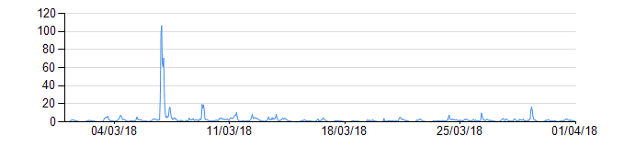
NO2  µg/m³ | 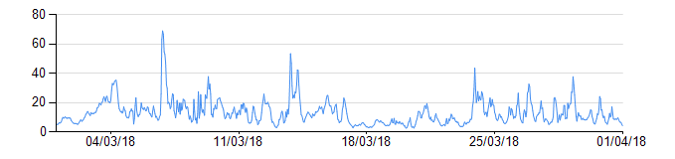
NOX  µg/m³ | 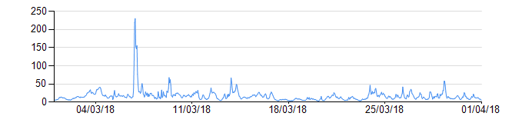
PM10  µg/m³ | 